Developed by Virus5600  
Twitter: [@SatchNavida](https://twitter.com/SatchNavida)  
Reddit: [u/SatchTFF](https://www.reddit.com/user/SatchTFF)  
Facebook: <fb.me/virus5600>  
Github: <github.com/virus5600>  
Discord: [discord.com/invite/gqWF7e8XuG](https://discord.com/invite/gqWF7e8XuG)

TABLE OF CONTENTS

**INTRODUCTION** . . . . . . . . . . . . . . . . . . . . . . . . . . . . . . . . . . . . 2  
 Description  
 Basic Information  
 Installation

**CONTENTS** . . . . . . . . . . . . . . . . . . . . . . . . . . . . . . . . . . . . . . . 4  
 Cannon Turret  
 Ballista

**INTRODUCTION**

**Description:**

Defensive Add-on is an add-on that allows players to place defensive turrets and traps to protect themselves, their creations, positions, and so on. The add-on adds ***Towers***, ***Traps***, ***Entities***, ***Structures***, ***Villager Types***, and ***Items*** to the game, which opens a lot of new capabilities, ideas, and creative imaginations for the players to explore.

**Basic Information:**

Author: Satch Navida (Virus5600)  
Minimum Required Game Version: 1.16.100  
Add-on Version: 1.0.0  
Dependencies: Defensive Measures (RP)  
Compatible with: Majority of add-ons.

**Installation:**

To install the Add-on, please follow the instructions provided below:

**<WINDOWS 10>**

1. **Extract** the contents of the archive anywhere in your desktop.
2. **Double click** the mcpacks and choose Minecraft Bedrock. Alternatively, you can right-click the mcpack and choose “Open with” option, then select Minecraft Bedrock.
3. Open Minecraft and create a new world. Alternatively, you can just use an existing world. Just make sure to have a backup copy of that world.
4. Enable both the **“Additional Modding Capabilities”** and **“Holiday Creator Features”** under the **“Experiments”** tab.
5. Go to **“Behavior Packs”** tab and activate **“Defensive Measures Add-on (BP)”**.
6. Go to **“Resource Packs”** tab and activate **“Defensive Measures Add-on (RP)”** if it is not activated yet.
7. Generate the world if you created a new one. If you use an existing world, you can proceed and load the world.
8. Enjoy!

**<MOBILE>**

1. **Extract** the contents of the archive to “Internal Storage/games/com.mojang/”.
2. Move the **Behavior Pack** **(BP)** archive to “games/com.mojang/behavior_packs”.
3. Move the **Resource Pack (RP)** archive to “games/com.mojang/resource_packs”.
4. Open Minecraft and create a new world. Alternatively, you can just use an existing world. Just make sure to have a backup copy of that world.
5. Enable both the **“Additional Modding Capabilities”** and **“Holiday Creator Features”** under the **“Experiments”** tab.
6. Go to **“Behavior Packs”** tab and activate **“Defensive Measures Add-on (BP)”**.
7. Go to **“Resource Packs”** tab and activate **“Defensive Measures Add-on (RP)”** if it is not activated yet.
8. Generate the world if you created a new one. If you use an existing world, you can proceed and load the world.
9. Enjoy!

**CONTENTS**

**Turrets:**

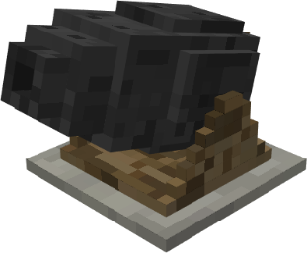**Cannon Turret** - The very first turret implemented in the add-on. It shoots cannonballs that explodes upon impact.

Damage: 15 (C:\Users\karls\AppData\Local\Microsoft\Windows\INetCache\Content.Word\heart icon (full).png * 7 + heart icon (half) * 1)  
Range: 16 blocks  
Attack Speed: 0.2 shots/s  
Is AoE: YES  
Health: 50 (C:\Users\karls\AppData\Local\Microsoft\Windows\INetCache\Content.Word\heart icon (full).png * 25)  
Repairable: YES  
Repair Items:  
 > Wood Planks: +1 ( * 1)  
 > Iron Nugget: +1 (C:\Users\karls\AppData\Local\Microsoft\Windows\INetCache\Content.Word\heart icon (half).png * 1)  
 > Iron Ingot: +10 (C:\Users\karls\AppData\Local\Microsoft\Windows\INetCache\Content.Word\heart icon (full).png * 5)  
 > Iron Block: +100 (C:\Users\karls\AppData\Local\Microsoft\Windows\INetCache\Content.Word\heart icon (full).png * 50) & Absorption 3/+6 ( * 3)



**Ballista** - One of the cheapest turrets to build in the add-on. It shoots arrows that deals low damages to enemy.

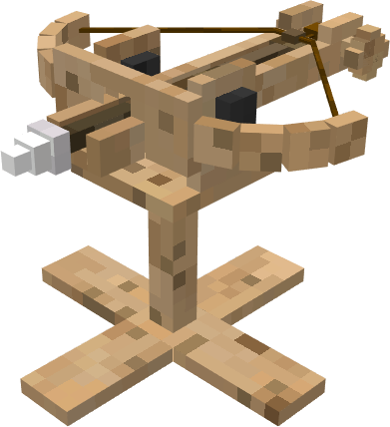

Damage: 1-4 (heart icon (half)*1 - C:\Users\karls\AppData\Local\Microsoft\Windows\INetCache\Content.Word\heart icon (full).png*2)  
Range: 16 blocks  
Attack Speed: 0.5 shots/s  
Is AOE: NO  
Health: 25 (heart icon (half)*1 + C:\Users\karls\AppData\Local\Microsoft\Windows\INetCache\Content.Word\heart icon (full).png*12)  
Repairable: YES  
Repair Items:  
 > Stick: +1(heart icon (half) * 1)  
 > String: +1 (heart icon (half) * 1)  
 >Wood Planks: +3 (C:\Users\karls\AppData\Local\Microsoft\Windows\INetCache\Content.Word\heart icon (half).png * 1 + C:\Users\karls\AppData\Local\Microsoft\Windows\INetCache\Content.Word\heart icon (full).png * 1)  
 > Wood: +15 (C:\Users\karls\AppData\Local\Microsoft\Windows\INetCache\Content.Word\heart icon (half).png * 1 + C:\Users\karls\AppData\Local\Microsoft\Windows\INetCache\Content.Word\heart icon (full).png * 7)

**MG Turret** – Perhaps one of the expensive turrets among others due to its iron plating and expensive ammo. It shoots a burst of 10 bullets and must reload after exhausting its ammo.

Damage: <TBA>  
Range: 16 blocks  
Attack Speed: 4 shots/s  
Is AOE: NO  
Health: 75 (heart icon (half)*1 + C:\Users\karls\AppData\Local\Microsoft\Windows\INetCache\Content.Word\heart icon (full).png*37)  
Repairable: YES  
Repair Items:  
 > Iron Nugget: +1(heart icon (half) * 1)  
 > Iron Ingot: +10 (C:\Users\karls\AppData\Local\Microsoft\Windows\INetCache\Content.Word\heart icon (full).png * 5)  
 > Iron Block: +100 (C:\Users\karls\AppData\Local\Microsoft\Windows\INetCache\Content.Word\heart icon (full).png * 50) & Absorption 3/+6 ( * 3)